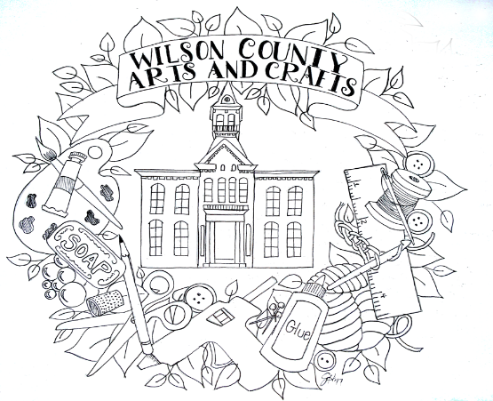

**No Floresville Festival**

**Peanut Logo allowed.**

**We have the right to refuse any item for sale that may feel unacceptable to W.C.A.C.**

**Questions on craft vendors**

**Call Janeth @**

**210-842-3861**

**Craft Vendor Application**

**Deadline Fri. Sept. 29th**

**NO EXCEPTIONS !**

**Mail application & check to W.C.A.C**

**c/o Janeth Tomlin**

**163 County Road 157**

**Floresville, Tx. 78114**

**80th Floresville Peanut Festival 2024**

**Fri. Oct. 11th & Sat. Oct. 12th**

**Our spaces are 10x10. NOT 12x12. It has become a problem with vendors who put up 12x12 canopies in the past. You can not block the aisles you’ll be moved to a different space. We need to have walking space for our patrons, wheelchairs, and baby strollers. Bring your own electrical cords, garden staples to hold down the cords, lights, etc. We do not except applications via email. There is a $35.00 fee for return checks.**

1. 10x10 $100.00 ________ Name:__________________________ Phone # ________________________

Address __________________________ Description of crafts____________________________________________

____________________________________________________________________________________________

The earlier you submit your application along with your check/money order the sooner you may be able to get set up. Set up times for the first 24 vendors will be 10:00 A/M on Fri. Oct. 11th. After that it will be 2:00 PM for the rest of the vendors. You may come set up your canopy and leave come back on Sat. REMEMBER ROADS WILL BE CLOSED SAT. AM AT 8:00. DEADLINE FOR APPLICATIONS ACCEPTED FRI. SEPT. 27TH .

**Remember there is limited electricity.**

**You must clean up after yourself, we have a great place to set up our Arts & Crafts and we want to keep it.**

**Lots of new vendors joining us this year. Looking forward to seeing our regular vendors, don’t know what we do without you and new vendors. Last year it was a success. It’s been a work in progress. But getting better each year.**

**Thanks Ya’ll**